**Year 11- Geography Diagnostic Assessment- September 2021**

**Criterion A and D**

**Total Marks 40 (Criterion A-20, Criterion D-20)**

|  |  |  |  |  |
| --- | --- | --- | --- | --- |
| Criterion A: Knowing and Understanding | | | | |
| **0** | **1-2** | **3-4** | **5-6** | **7-8** |
| The student does not reach a standard described by any of the descriptors given below. | The student:  i. uses **limited** relevant terminology  ii. demonstrates **basic** knowledge and understanding of content and concepts with **minimal** descriptions and/or examples. | The student:  i. uses **some** terminology **accurately** and **appropriately**  ii. demonstrates **adequate** knowledge and understanding of content and concepts through **satisfactory** descriptions, explanations and examples. | The student:  i. uses a **range** of terminology **accurately** and **appropriately**  ii. demonstrates **substantial** knowledge and understanding of content and concepts through **accurate** descriptions, explanations and examples. | The student:  i. **consistently** uses **a wide range** of terminology **effectively**  ii. demonstrates **detailed** knowledge and understanding of content and concepts through **thorough**, **accurate** descriptions, explanations and examples.  . |

|  |  |  |  |  |
| --- | --- | --- | --- | --- |
| Criterion D: thinking critically | | | | |
| **0** | **1-2** | **3-4** | **5-6** | **7-8** |
| The student does not reach a standard described by any of the descriptors given below. | The student:  • **makes a limited attempt** to analyse concepts, events, issues, models or arguments  • **describes some** sources in terms of origin and purpose and recognizes **some** values and limitations  • **identifies** different perspectives  • makes connections between information **in a limited attempt** to make arguments. | The student:  • completes a **simple** analysis of concepts, events, issues, models or arguments  • completes a **simple analysis** and/or **evaluation** of some sources in terms of origin and purpose, recognizing values and limitations  • **identifies** different perspectives and their implications  • makes connections between information to make **simple** arguments. | The student:  • completes a **satisfactory** analysis of concepts, events, issues, models or arguments  • **satisfactorily analyses** and/or **evaluates a range** of sources in terms of origin and purpose, recognizing values and limitations  • **interprets** different perspectives and their implications  • synthesizes information to make **valid** arguments. | The student:  • completes a **detailed** analysis of concepts, events, issues, models or arguments  • **effectively analyses** and **evaluates a range** of sources in terms of origin and purpose, recognizing values and limitations  • **thoroughly interprets a range of** different perspectives and their implications  • synthesizes information to make **valid, well-supported** arguments. |

|  |  |  |
| --- | --- | --- |
| **Criterion A** | **Marks obtained: /20** | **Grade: /8** |
| **Criterion D** | **Marks obtained: /20** | **Grade: /8** |

Q1. Examine the map of world (Source A) showing population distribution.

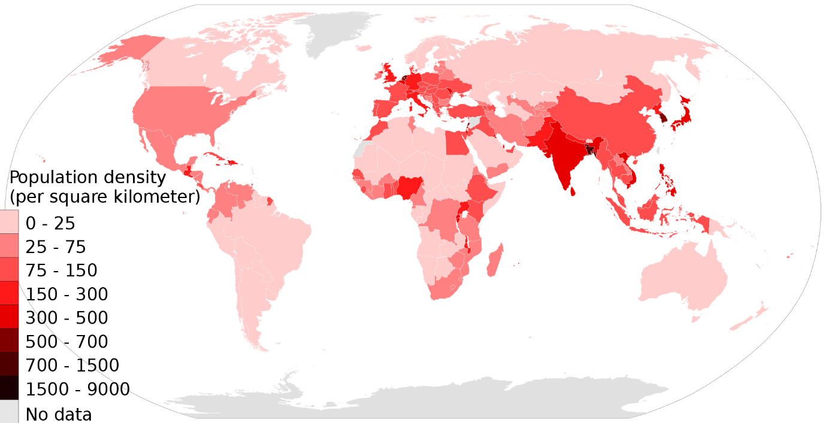

***Source A- Population density of the world.***

1. **Describe** the distribution of population. (A-4)
2. **Identify** two areas which have a population density of 1500- 9000 per square km. (A-2)
3. **Suggest** one reasons for the high population density in each of the places you have identified. (D-2 +2)

Area 1: ……………………

Reason

Area 2: ……………………

Reason

1. **Explain** with an example why some countries need government intervention to control its population growth. (A-4, D- 4)

Q.2 Examine the population pyramids of two countries in Source B and answer the questions that follow.

(i) **Describe** two features of the population pyramid of Japan. (A- 2)

(ii) **Compar**e Japan’s population of 0-4 years to that of Ethiopia. (D-2)

(iii) **Suggest** one problem Japan is likely to face in the future. (D-2)

(iv) **Suggest** one benefit that Ethiopia is likely to enjoy in the future. (D-2

(vi) Discuss how an ageing population can bring both benefits and costs to society. Use examples in your answer. (A- 8, D-6)

***Source B shows population pyramids of Japan and Ethiopia***